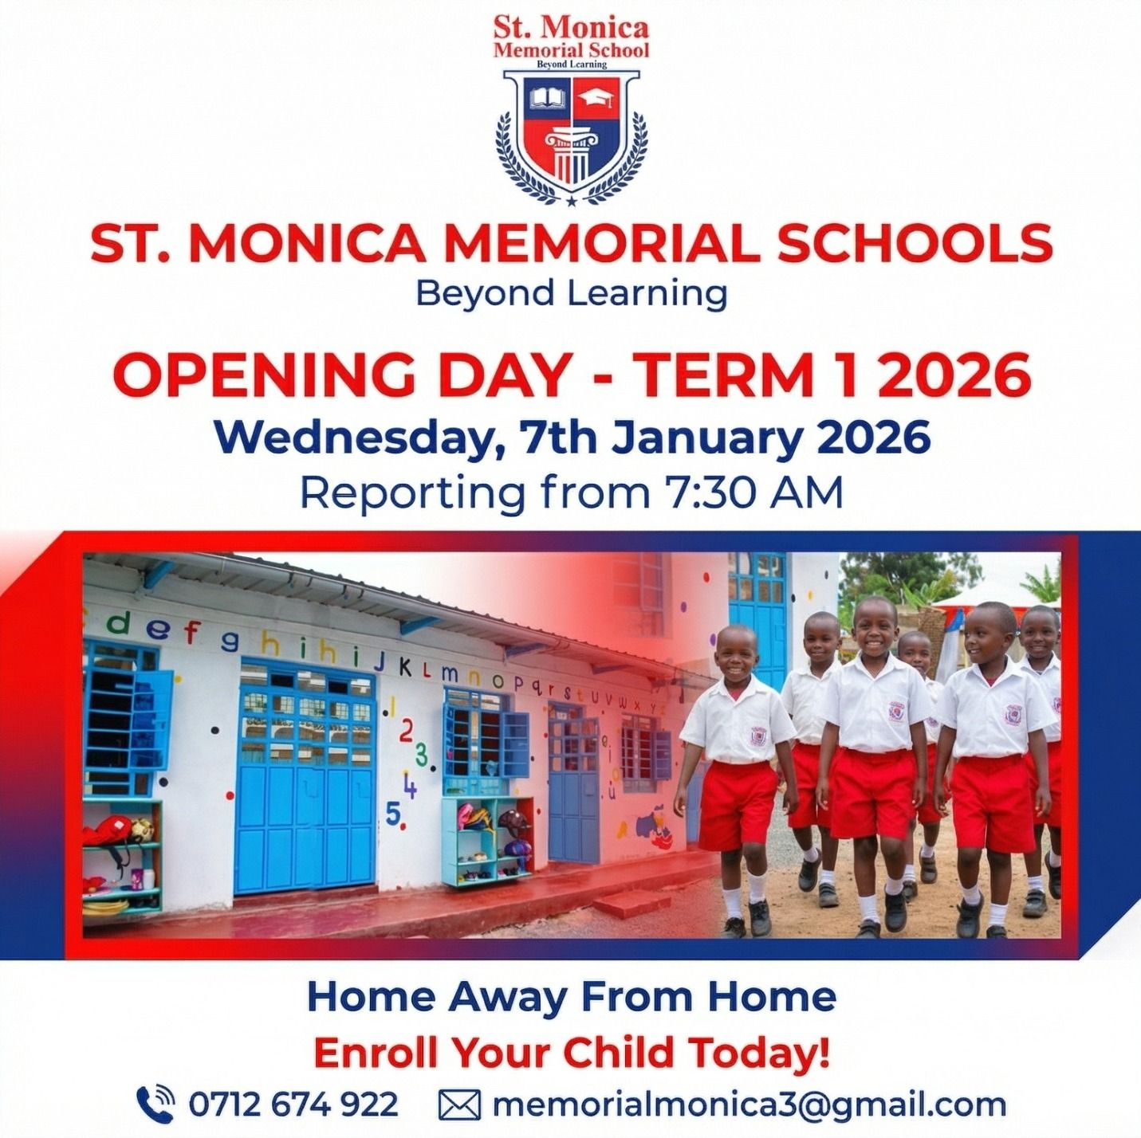

Student Discipline Policy

Policy Statement
St Monica School will maintain a fair and consistent system for handling both minor and major behavioral infractions. The school aims to cultivate good character and behavioral competencies in its learners.

Policy Objectives
- To outline the minimum behavioural standards expected of a St Monica School student.
- To inspire good behavior among students.
- To set out the procedure and consequences of major and minor infractions.
- To create a safe and conducive learning environment for all learners.
- To promote respect for self and others.
- To promote respect for property.

Scope of the Policy
This policy applies to the entire student body of St Monica School, guardians and parents, the staff members involved in disciplinary proceedings, and ultimately, the School Management Board.

Behavioral Expectations
St Monica School students are expected to generally behave as follows:
- a) To treat everyone with kindness and respect.
- b) To avoid touching others inappropriately.
- c) To employ the use of appropriate language.
- d) To refrain from causing harm, name-calling, or bullying other students.
- e) To immediately notify a member of staff of any behavioural infractions.

Minor Infractions
These will be commonly handled by teaching staff in a classroom setup. These include, but are not limited to: chewing gum, noise making, tardiness, school uniform violations, insolence, insults, inappropriate language, defiance, and improper gestures and gesticulations.
However, repetitive or excessive minor infractions can amount to major infractions resulting in initiation of disciplinary proceedings and greater sanctions.
Sanctions for Minor Infractions: Includes reprimanding the learner in subject or seeking the help of parents, guardians, or administrators.

Major Infractions
Major infractions warrant the intervention of a school administrator. For instance, when a learner's actions infringe on the safety of those around them, or if they demonstrate repeated defiance of school rules and members of staff, or disrupt the learning of others, they may be dismissed from class and referred to a designated administrator.
- Reporting Obligations: Students have a moral obligation to report sightings or knowledge of major infractions around them. Failure to report will result in shared culpability.
- False Reports & Retaliation: Students shall not make false or malicious reports. Retaliation against those who report infractions or who are called upon as a witness in an investigation shall be treated as a major infraction.

Examples of Major Infractions:
Major infractions include, but are not limited to:
- Drug possession and drug use
- Possession of dangerous weapons
- Bullying and injuring fellow learners
- Retaliation
- Destruction of school property
- Theft
- Fighting
- Inappropriate sexual behaviour
- Ignoring directives given by teachers and/or any other form of authority
- Any such behavior that is sanctioned by the law

Sanctions for Major Infractions:
Sanctions for major infractions include suspension, expulsion, restitution, emergency removal, or legal sanctions under the law of Kenya.

Disciplinary Proceedings
Upon referral of a Major infraction to an administrator, disciplinary proceedings shall commence without delay and even then, not later than seven days from the report thereof. The report shall be writing or caused to be in writing.
The administrator(s) shall summon the parent or guardian of the subject learner, with the school, whereupon in tandem with the principle of fair hearing, the learner, with the assistance of their guardian or parent, shall respond to the report.
In the event that the said guardian or parent refuses, fails or neglects to honour the summons without showing reasonable cause, the administrator(s) shall send the learner in subject home to fetch the guardian or parent.
The learner may call the witnesses or present evidence during the hearing.
The proceedings of such disciplinary hearing shall be in writing, and confidential unless such confidentiality waives by operation of the law.
Upon completion of the proceedings, the school Board shall deliberate and make its decision not later than fourteen (14) days from the hearing thereof.
The decision of the school board shall be final and binding.

Reward for positive Behaviour
In order to inspire good behavior, St. Monica School shall reward students during the Annual Prize Giving days, for positive behaviour including the most disciplined Student.
Further, members of staff shall from time to time applaud and praise well behaved students in a bid to encourage good behaviour.

Review
This policy shall be subject to review every two years, or earlier as the need arises.

